Recipe Reading Instructions: Use the Apple Cinnamon Streusel Muffin Recipe below to complete this section. List all cooking tools and equipment in the recipe and explain in detail how the item is used in the recipe.

Apple Cinnamon Streusel Muffins

# Apple Cinnamon Ingredients: Chocolate Chip Ingredients:

|  |  |  |  |
| --- | --- | --- | --- |
| 2 c. | Bisquick Mix |  | 1 c. Flour |
| 1/4 c. | Sugar |  | ¼ c. Sugar |
| 1 tsp. | Cinnamon |  | 1 ½ t. Baking Powder |
| 1 | Egg |  | ¼ t. Salt |
| 1/3 c. | Applesauce |  | 1 Egg |
| 1/4 c. | Milk |  | ¼ c. Milk Plus 2 T. |
| 2 T. | Vegetable Oil |  | ¼ c. Applesauce  1/3 c. Mini Chocolate Chips |

# Directions:

* Preheat oven to 400°F. Spray muffin tin with non-stick cooking spray.
* In a mixing bowl stir all dry ingredients for muffins together with a wire whisk and make a well in the center.
* In a separate bowl mix all wet ingredients for muffins until blended well and add to dry ingredients and stir until just moistened. Divide evenly among 6 muffin cups, filling 3/4 full.
* Bake 18-20 min or until toothpick comes out clean. Cool 5 min and remove from pan on to a cooling rack.

**Equipment Needed:** (Minimum of 8 items) **How it is Used in Recipe:**

Equipment Identification Quiz: Do your best WITHOUT looking back at the equipment slides.

1. 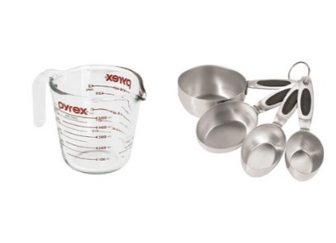 2. 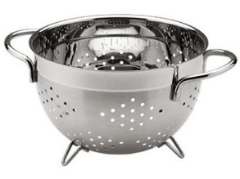 3. 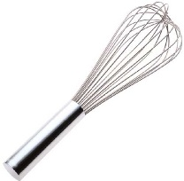 4.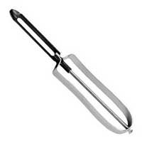

5.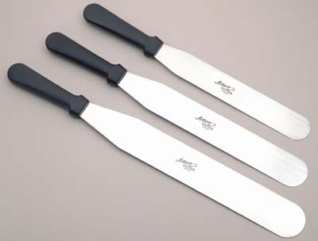 6.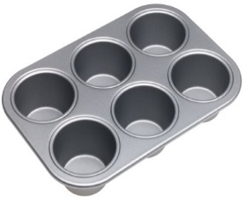 7.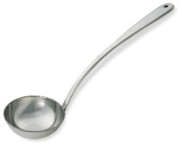

8.  9. 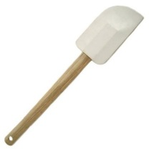 10. C:\Documents and Settings\brennanst\Local Settings\Temporary Internet Files\Content.IE5\UVG3B1ZZ\MC900341000[1].wmf11. 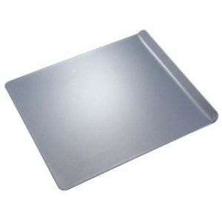

12. 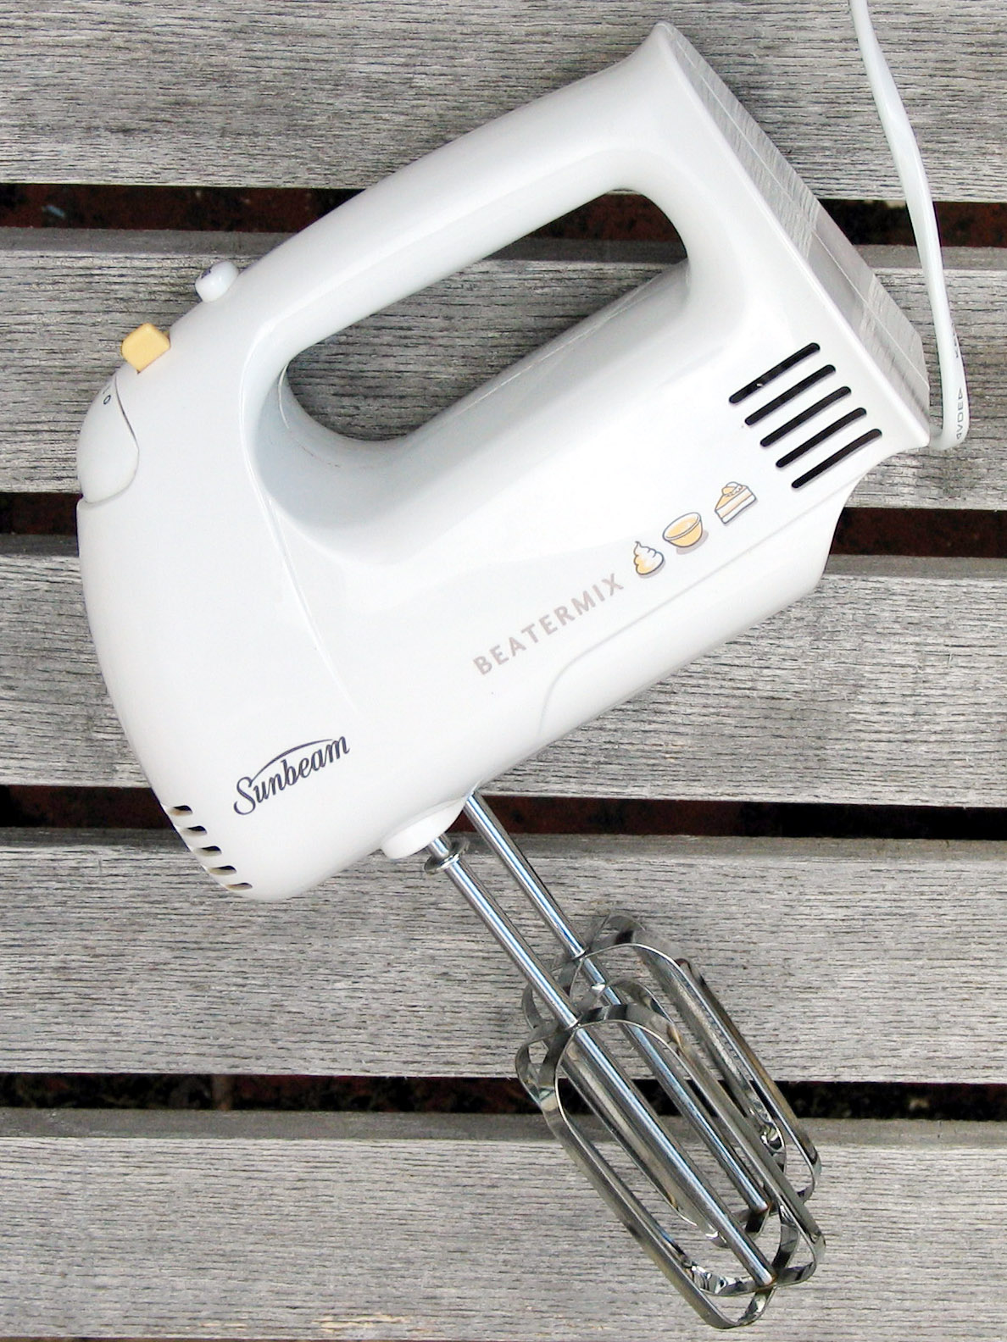 13. 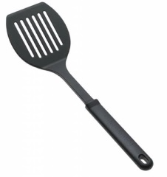 14. 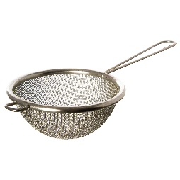 15. 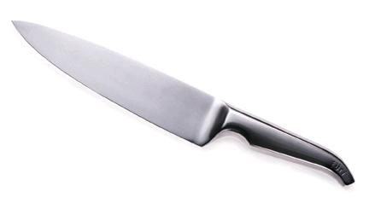

|  |  |
| --- | --- |
| NAME | USED FOR |
| 1. |  |
| 2. |  |
| 3. |  |
| 4. |  |
| 5. |  |
| 6. |  |
| 7. |  |
| 8. |  |
| 9. |  |
| 10. |  |
| 11. |  |
| 12. |  |
| 13. |  |
| 14. |  |
| 15. |  |